**DEAL-ME!!**

**Increment 3**

Sai Praneeth Paruchuri(30)

Mounika karampudi(17)

Divya Sree Vintha(45)

Sivaji Ganesh Kandimalla(16)

**Introduction**

In general, travelling is a hobby for many people in this world. While travelling we are more likely to check out the new places around that area to plan our visit accordingly. It is always interesting to check on available deals of the places nearby which makes our visit more economical. While travelling people are more likely to use their smart phones for navigation as well as checking out the places for visiting purposes. Smart phones nowadays plays major role in travelling, acting like a guide for the routes and explore the places nearby.

Using these features of smartphone, we tried to implement a new mobile application where we can explore our places of interest along with the available deals at those particular places with more ease

**Aim/Goals:**

Our Aim is to design a mobile application in which we can explore all the places of our choice and deals available at a given location or city. The application should be flexible enough to handle the smart cash through e-wallets and also save their places of future visit as wishlist.

**System features:**

* User can pick their choice of places to explore nearby.
* The user can explore the places related to their interest at a given place and also at their current location.
* The user can find the available deals and coupons of the chosen places nearby their location.
* The user can save places for their future visit as a wish list.
* The user have the privilege of scanning the coupons which are readily available with him/her.
* The user can also navigate to the particular place of their choice from their current location.

**Work-Flow**

* This app can be used to either get the places nearby and also the deals near you. There are a bunch of place types like restaurants, cafe, shopping from which you can choose multiple.
* These places are displayed as markers on the map. On clicking the info box of a marker, another activity is opened displaying the complete details of the place.
* Here, you can save the place as a wish list, one you’d want to visit in the future or get directions to the place from your location.
* You can also select deal types to be displayed on the map from a set of deal types. On clicking the info window of a marker, the activity similar to that of places is displayed.
* Here, the complete details of a deal including the expiration date and a link to the coupons are displayed. You can save this deal in your wallet, another feature of the app, to use it in the future.
* A person can also scan the QR code of a coupon to access it or save it in his wallet.

**UML Diagrams**

**Use Case Diagram:**

A use case diagram is a graphic depiction of the interactions among the elements of a system. Ause case is a methodology used in system analysis to identify, clarify, and organize system requirements.

Use case diagram of the Application

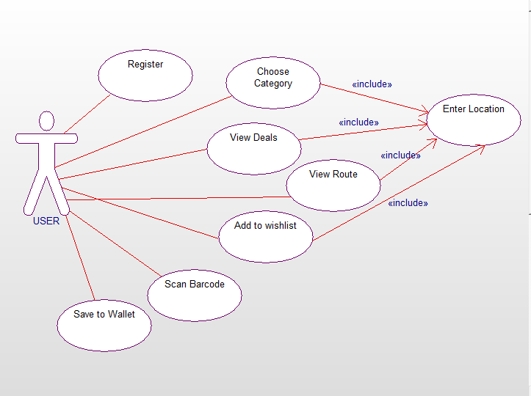

**Sequence Diagram**:

A sequence diagram shows object interactions arranged in time sequence. It depicts the objects and classes involved in the scenario and the sequence of messages exchanged between the objects needed to carry out the functionality of the particular scenario.

A sample sequence diagram of user finding a deal for the place of his choice.

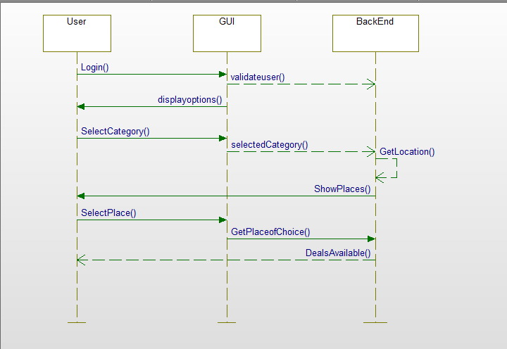

**IMPLEMENTATION:**

**Screenshots**

This is the start screen of the app, where you have to have a username and password to login. If you do not have the login credentials you can register by clicking the text below asking you to register.

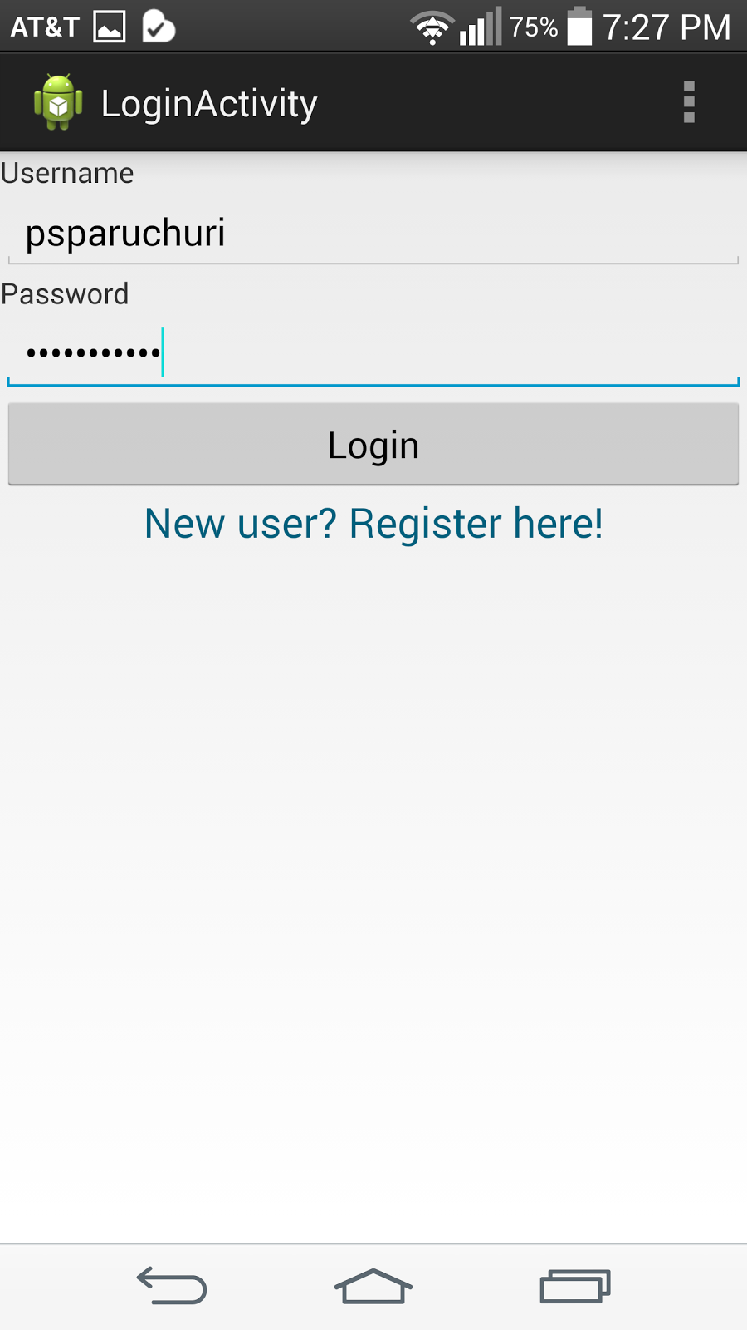

This is the registration screen.

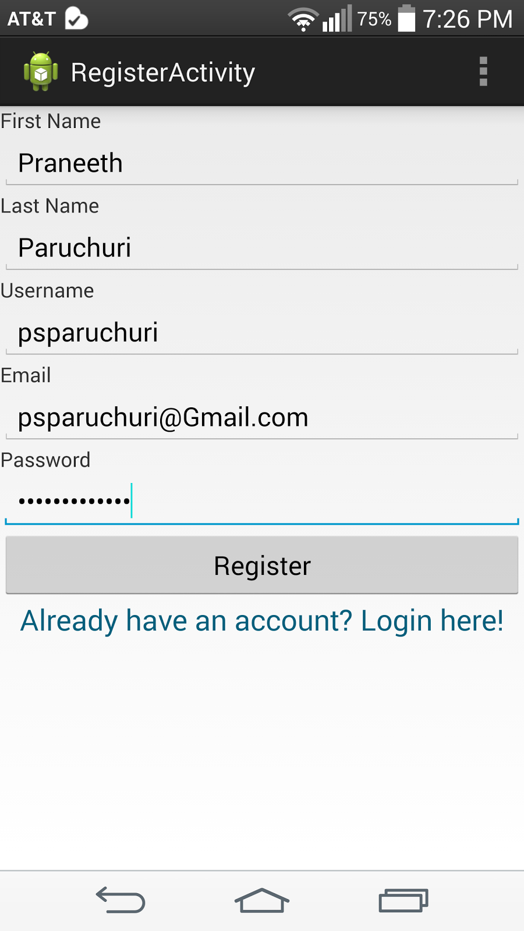

If you have successfully registered you’re diverted back to the login screen where you’re asked to login again. On successful attempt, a toast is displayed and the main activity is called. We’ve written our own web services for the registration and login pages.

In the Main Activity, you can see four buttons.

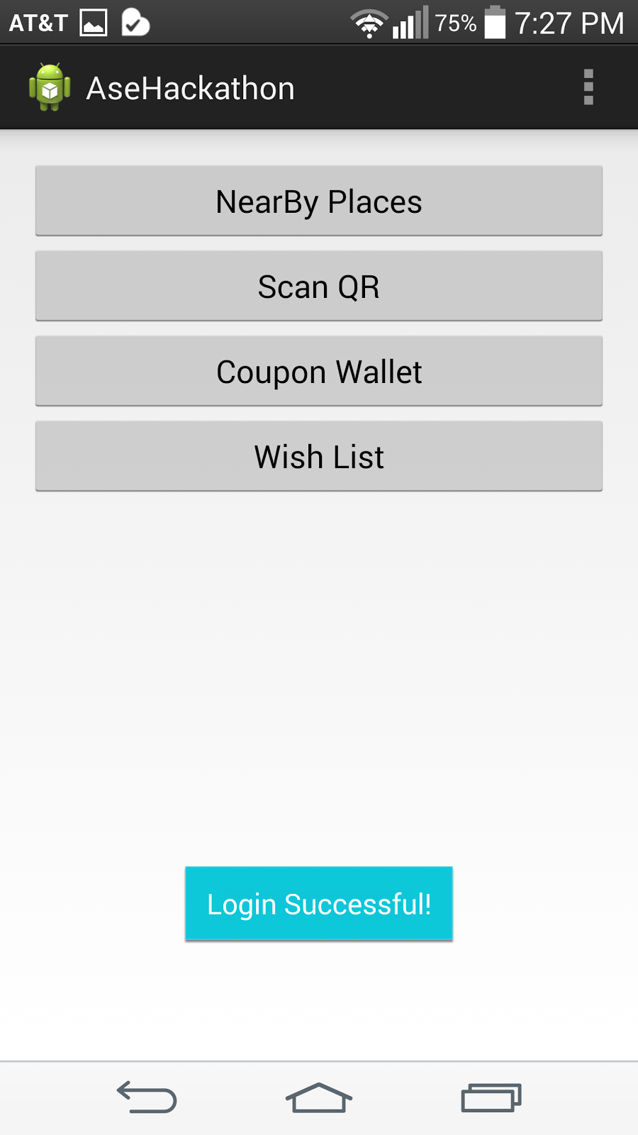

When you click the NearBy Places button, a list of place types is displayed. Here, you can choose more than one place types to be displayed near you.

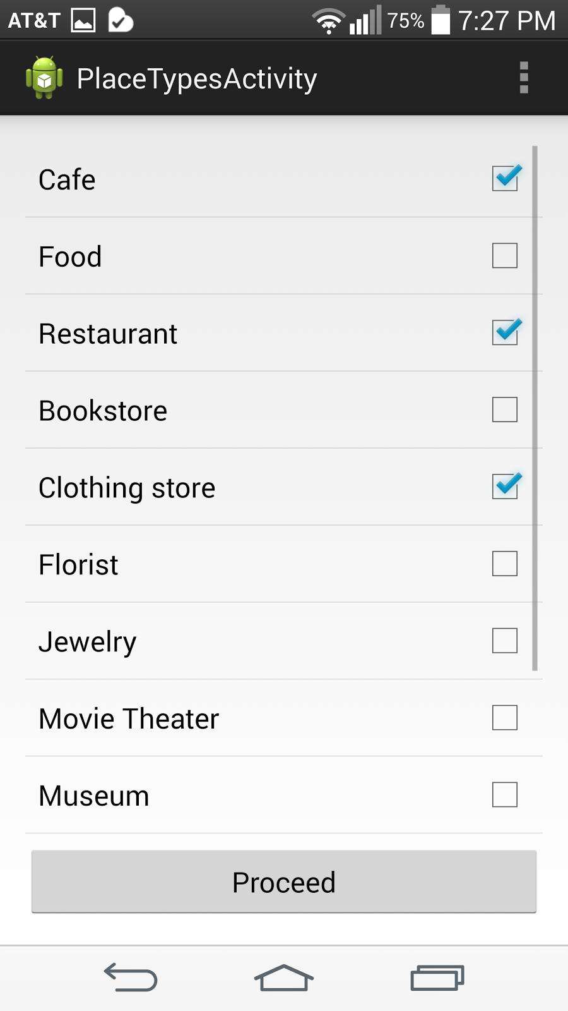

Suppose I pick the above three, these places are displayed as pointers on the map.

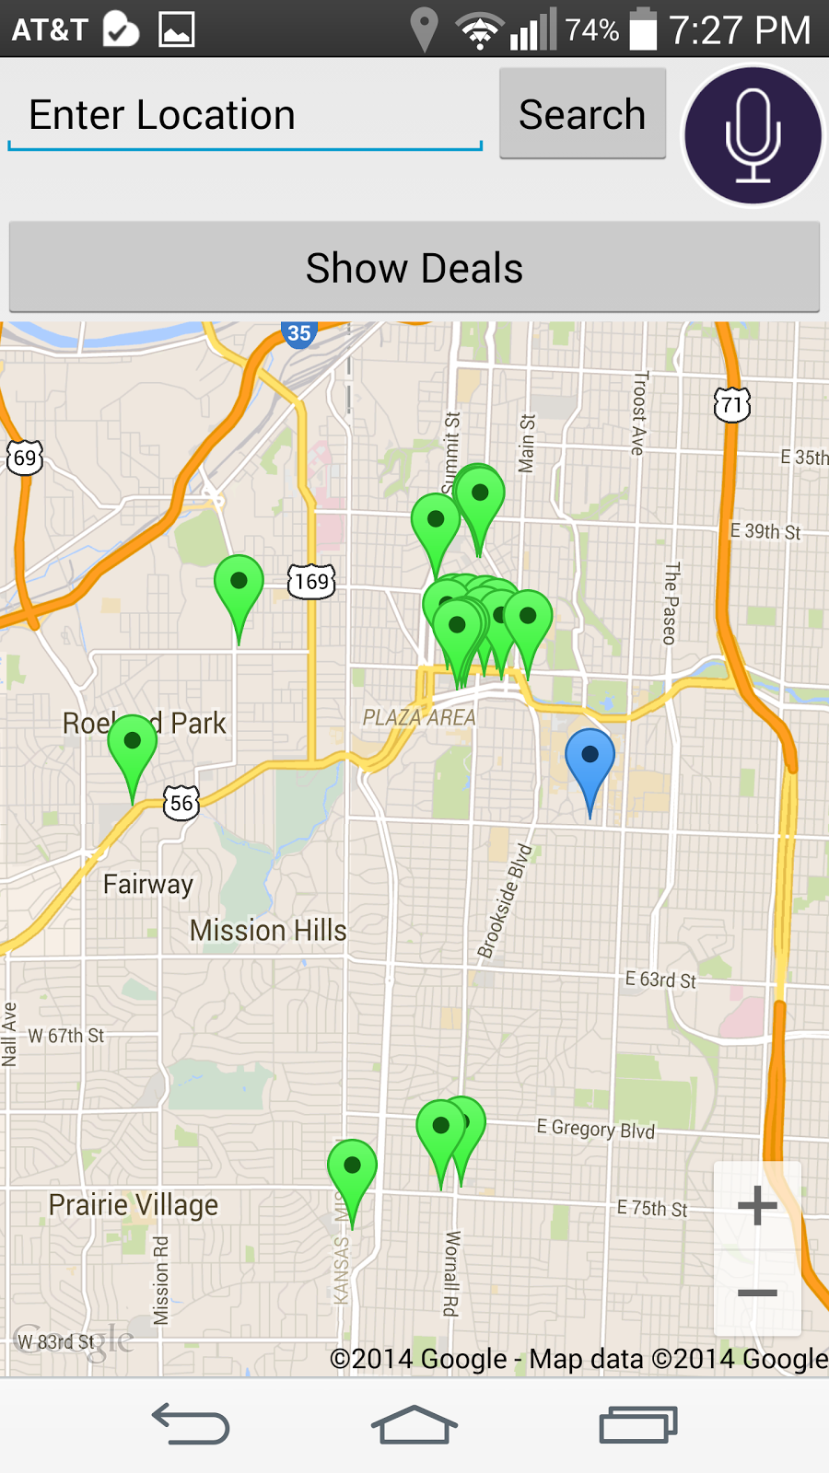

The blue pointer on the map shows your location and the green pointers are the selected place types.

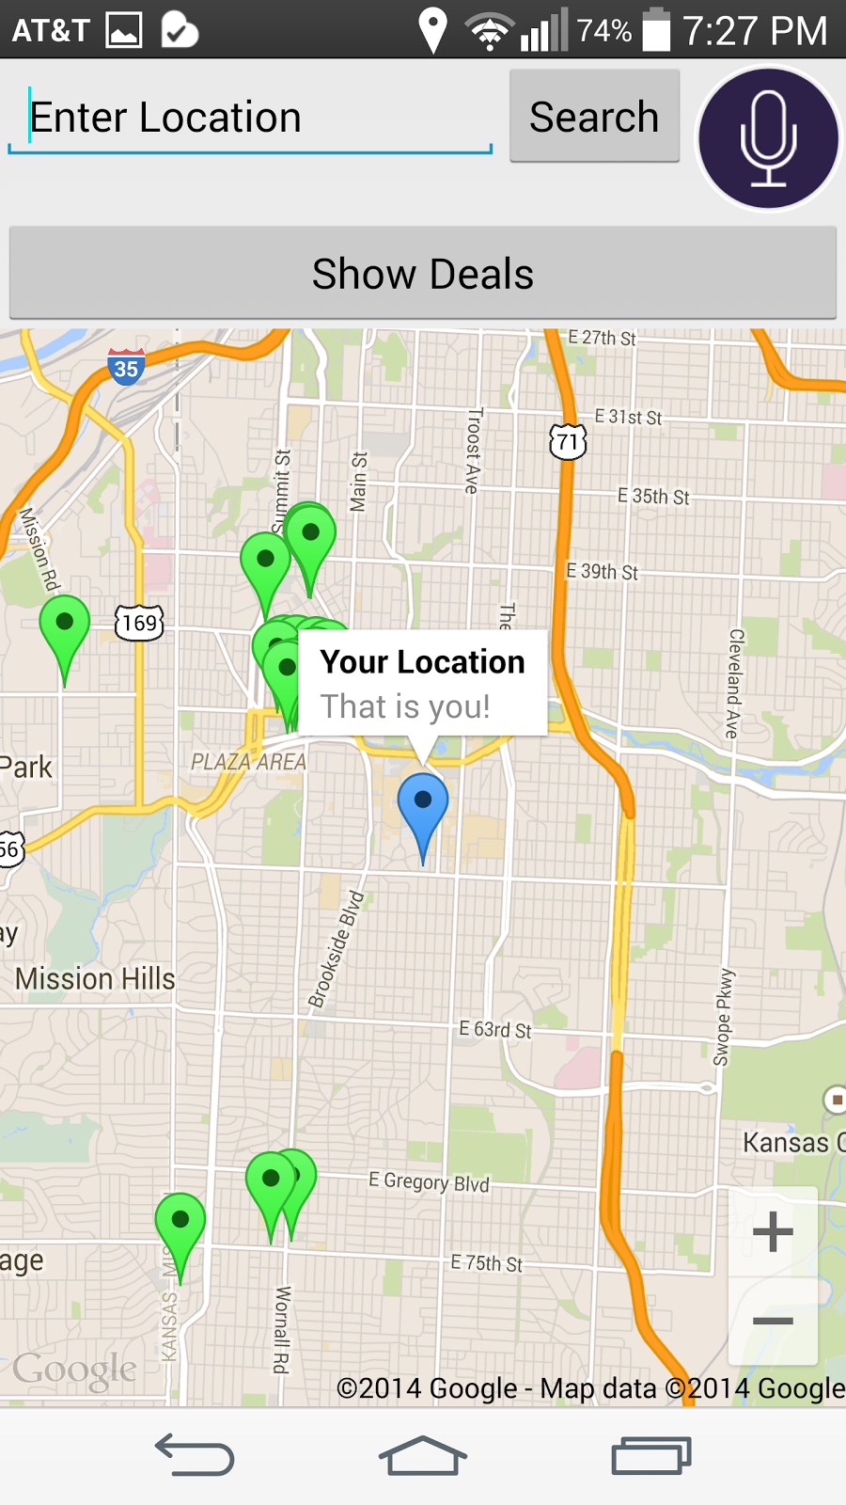

When you click a pointer on the map it displays the place name, like the name of the restaurant or a coffee shop, and the address of the place.

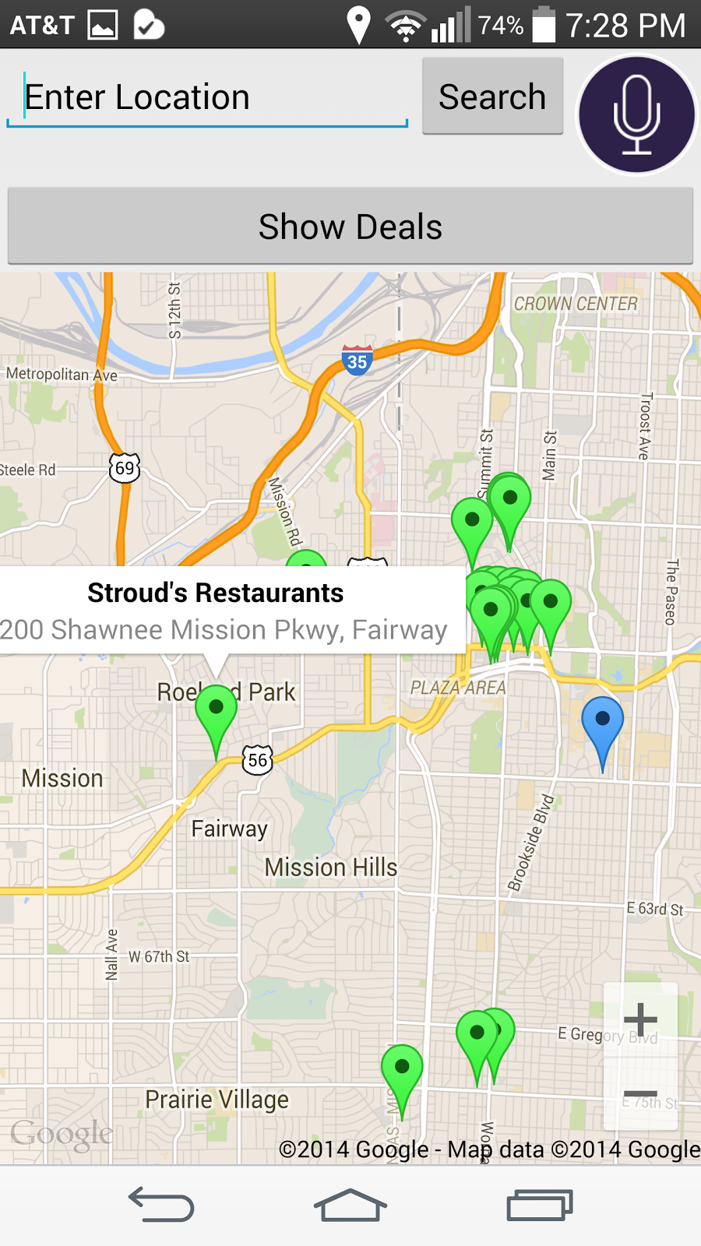

You can also enter a custom place and find the places near that place by using the edit text showing Enter Location. We’ve also implemented the speech to text as shown below.

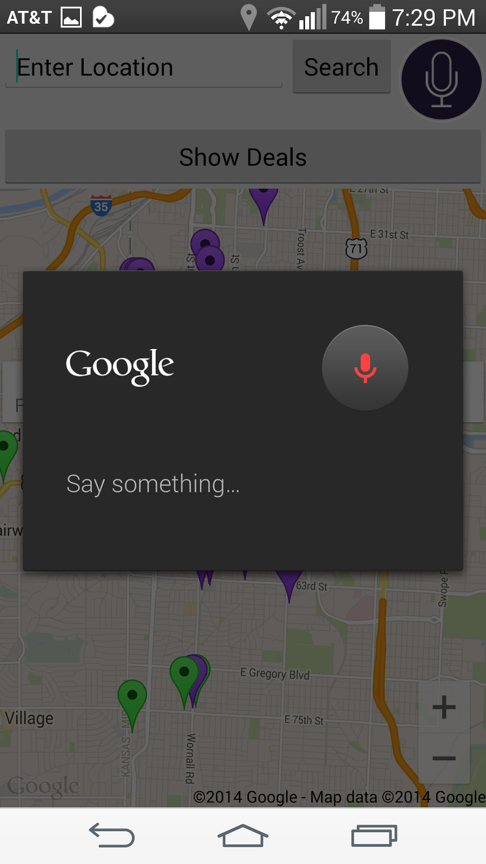

When you click the marker, an info window is displayed as said earlier. Now, if you click the info window of a place, the complete details of the place are displayed in a separate activity, with two buttons at the bottom. One for the directions to the place and the other to save to your wish list.

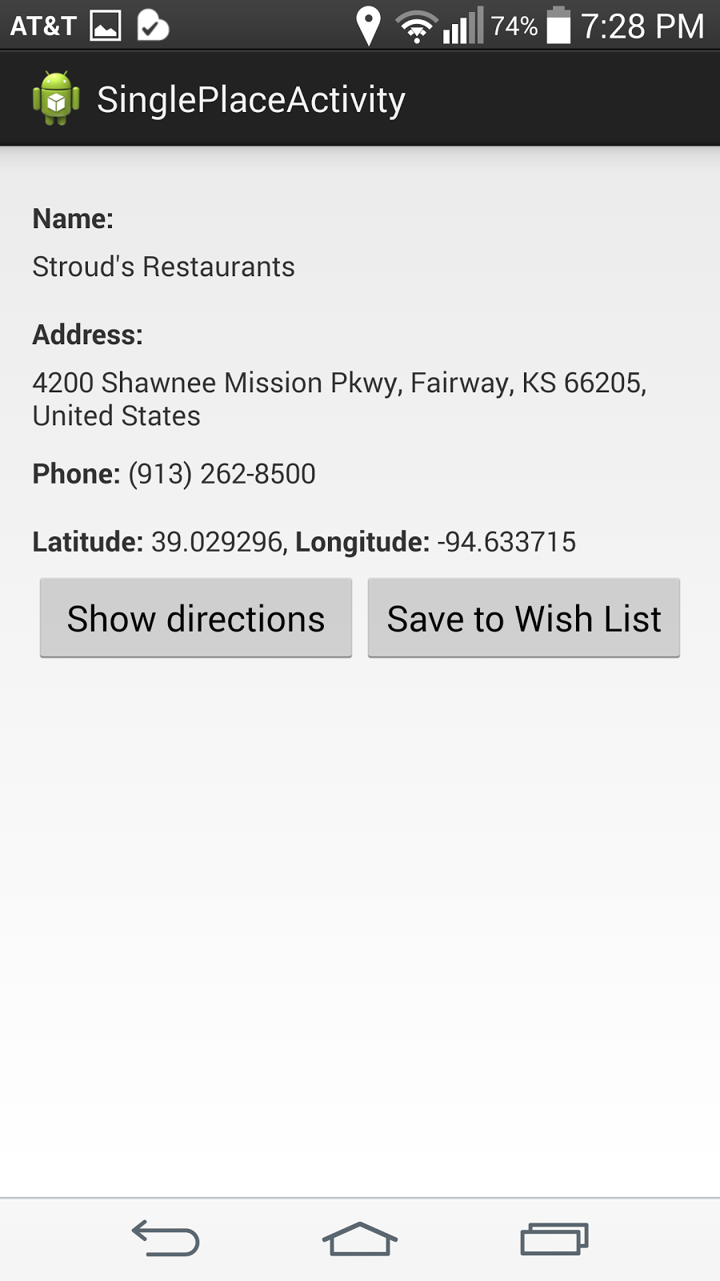

When you click the show directions button, this gives the directions from your location to the place location.

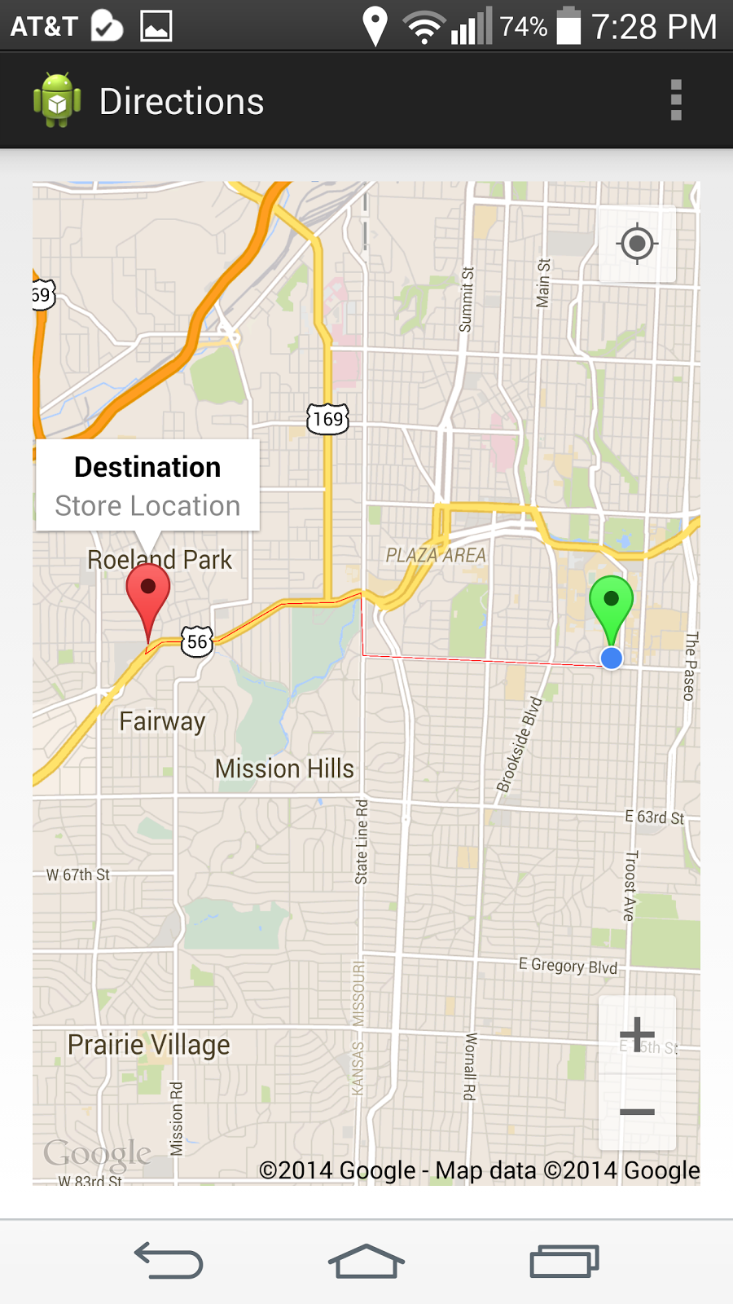

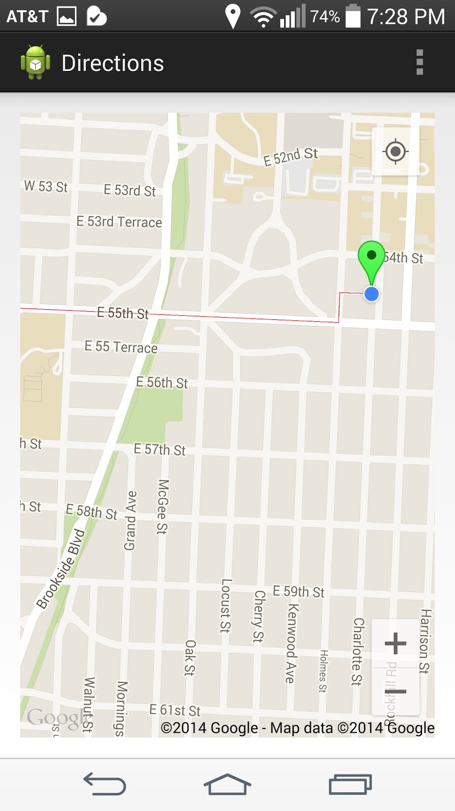

If you click the button, Save to Wish List, a toast is displayed if successful. Wish List is something a person wants to try out in the future or some place he loves and doesn’t want to miss.

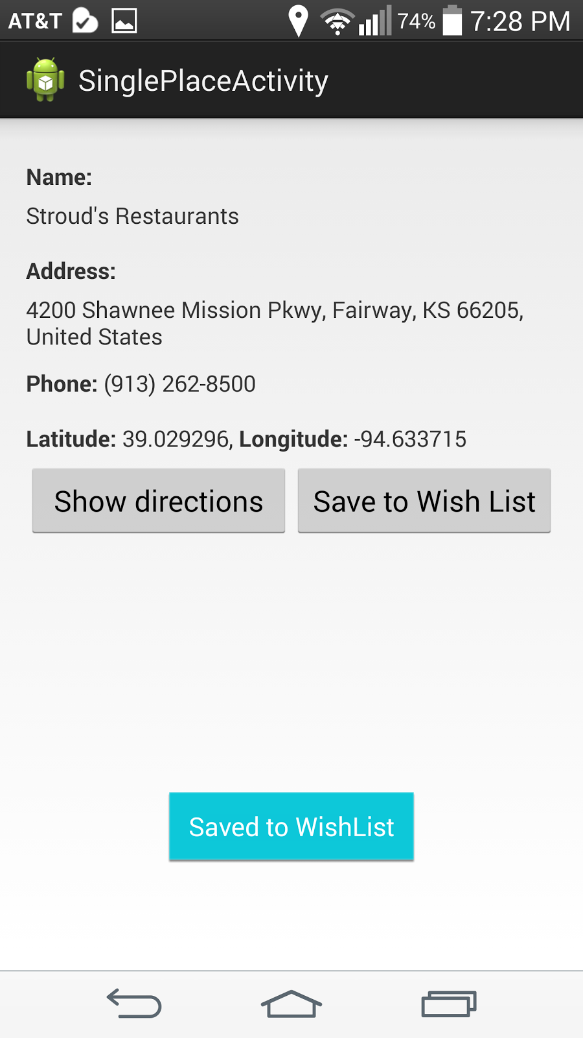

Now, if you want to also check the deals that are going on near you, back in the map activity showing us the places, click the show deals button. This calls an activity displaying different types of deals. You can select more than one to be displayed on the map.

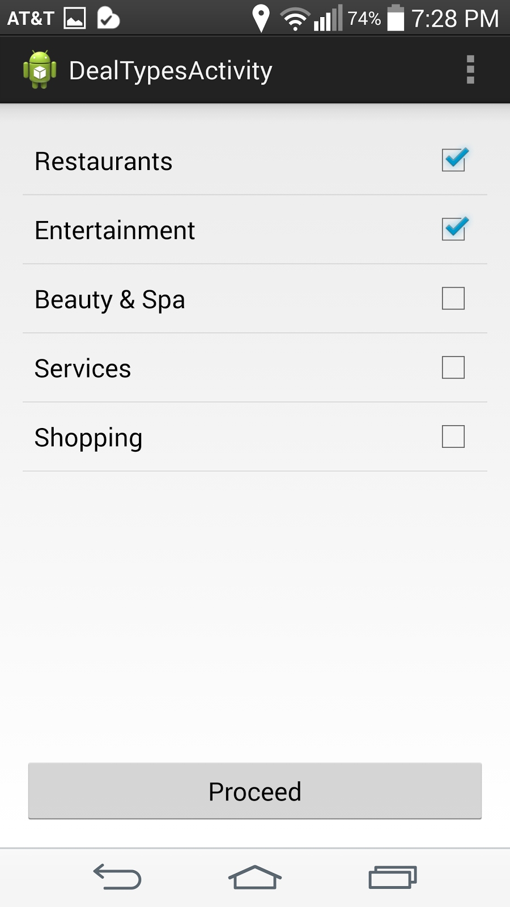

These deals are displayed on the map as violet markers.

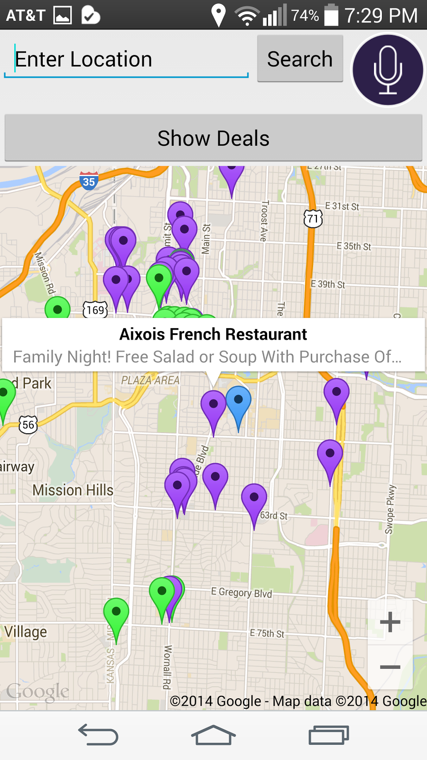

When you click on a deal marker, an info window with the store name and the deal info are revealed.

When you click on the info window, an activity is opened with complete deal details which include the deal information, store name, phone number, number of deals in the store, expiration date of the deal.

This activity has two buttons, to show the directions to the store and save to the wallet.

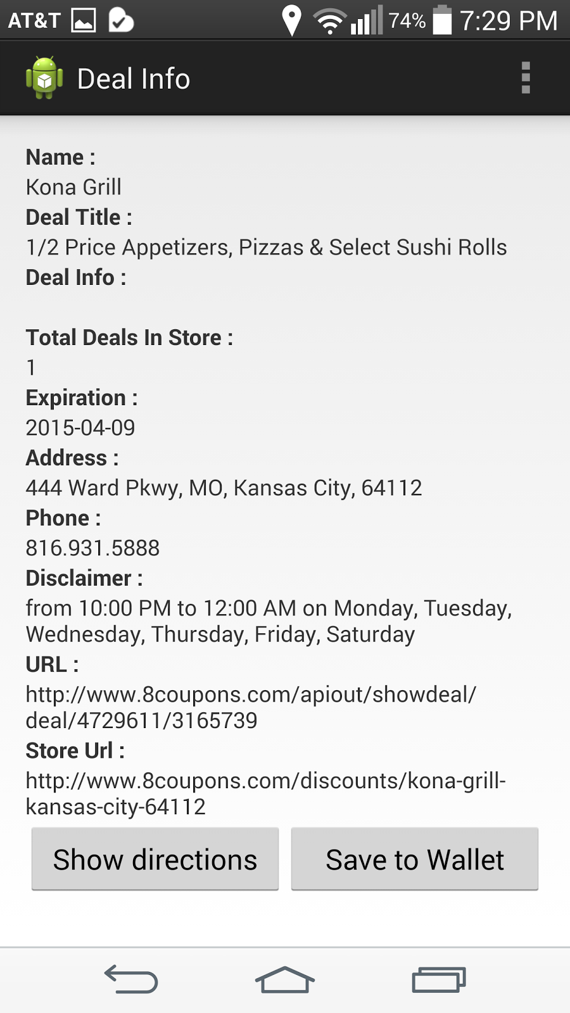

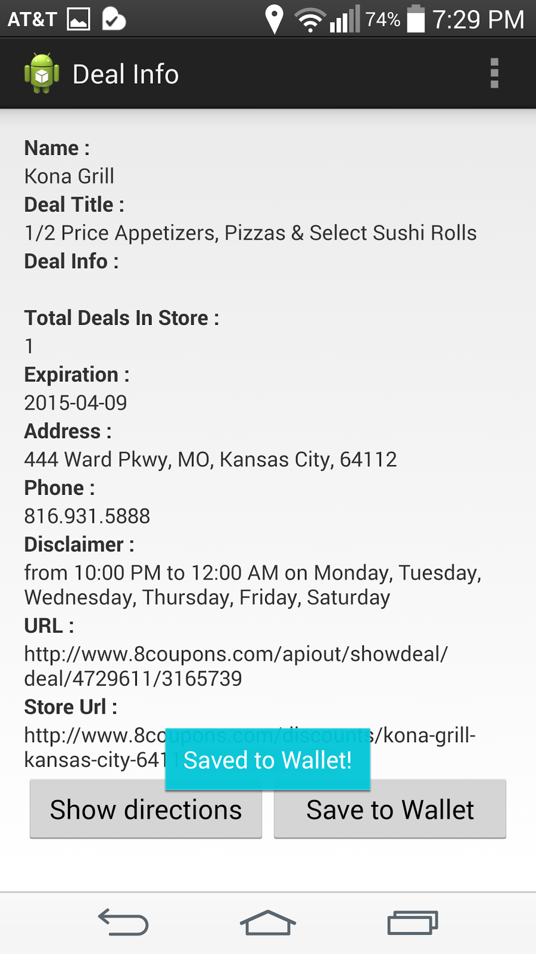

You can check the places you saved in the wish list by clicking the button on main activity. This displays a clickable list view of the places saved.

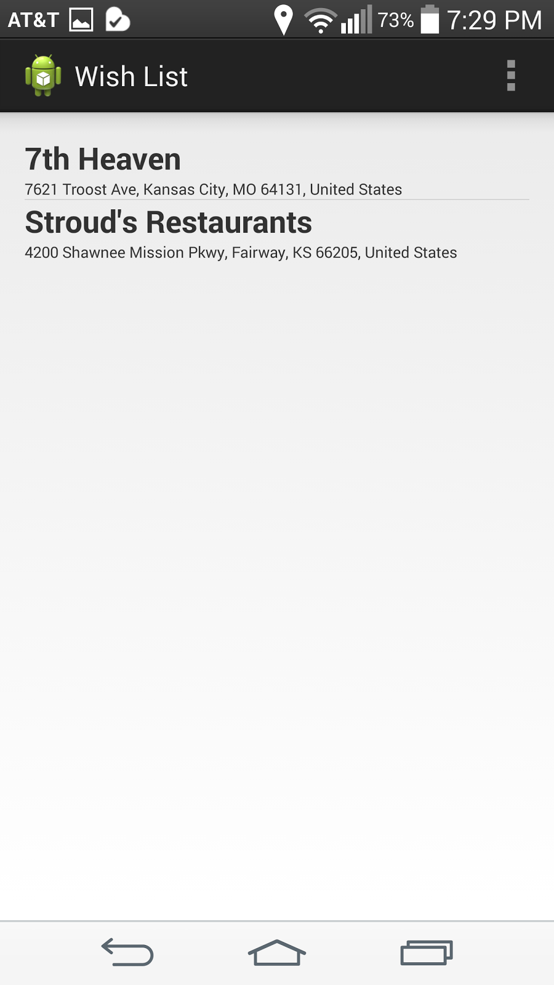

**Future work/Limitations now**

1. We wanted to get the deals by clicking on the info window of your location, which wasn’t possible now.
2. The QR code scanner functionality deserved by the app is not up to the limit.
3. We are facing some problems with the Rest Web Services we’ve written.
4. Some issues with the expiration date functionality.

**Project Management**

We have shared our work among ourselves using Scrum Do.

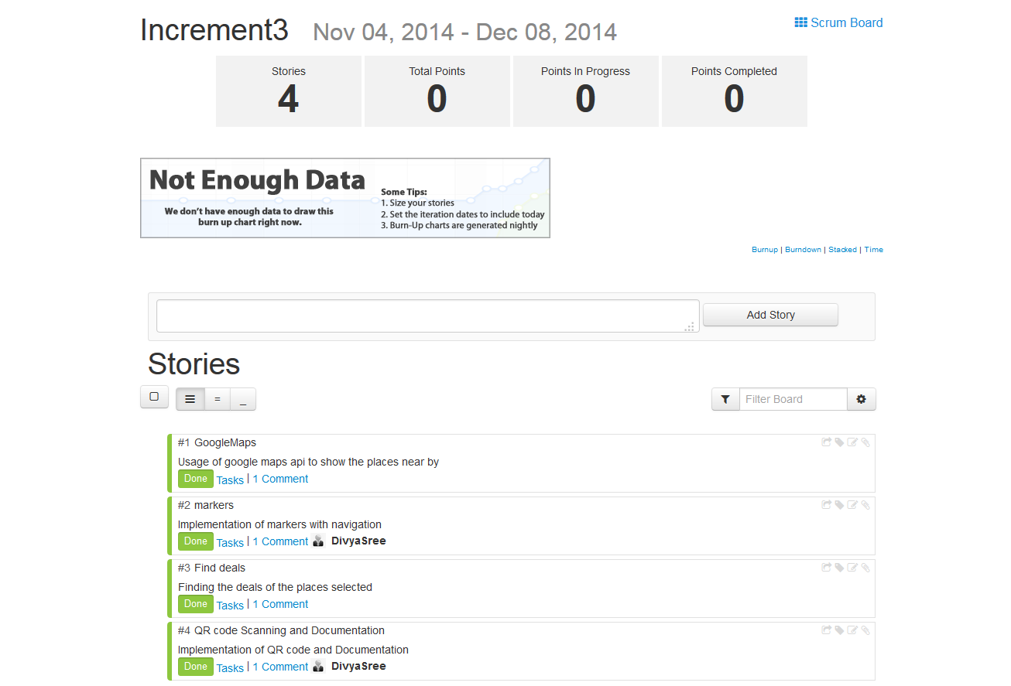

The URL for Scrum Do

https://www.scrumdo.com/projects/project/deal-me/iteration/116761

**References**

<http://www.androidhive.info/2012/08/android-working-with-google-places-and-maps-tutorial/>

<https://code.google.com/p/google-api-java-client/wiki/Setup>

<http://www.8coupons.com/api/getapi>

<http://www.8coupons.com/api/doc>

<http://www.androidhive.info/2012/01/android-json-parsing-tutorial/>

<http://wptrafficanalyzer.in/blog/dynamically-add-items-to-listview-in-android/>

<http://www.mkyong.com/java/how-to-compare-dates-in-java/>

**Github :**

<https://github.com/spp64/Ase-FInal-Incement>